
Company
Logotype

Cone Beam Computed Tomography- Report



Porur Dental X-rays & CBCT

Patient Name : Mr. Santhosh | Date of Report : 27.03.2024
Age/ Gender : 31 years/ Male | Region of Interest : CBCT Sectional Mandible
Referring doctor: Dr. Leo | Indication : Implant assessment
Clinical Notes: Nil
PATIENT INFORMATION

CBCT- Sectional Mandible provided
CBCT – IMAGE DETAILS

RADIOGRAPHIC INTERPRETATION

- Complete loss of crown and root structure in relation to 46, 48.
- The alveolar bone in relation to 46 is present with reduced bone density when compared to adjacent regions.

IMPLANT ASSESSMENT

 | 45 region | 46 region | 47 region
Sub-Crestal (in mm) | 8.33 | 5.23 | 11.37
Mid- Crestal (in mm) | 8.36 | 7.64 | 11.32
Distance between alveolar ridge and the inferior alveolar nerve canal (in mm) | 20.87 | 23.37 | 25.76
Distance between alveolar ridge and the inferior border of mandible (in mm) | 31.25 | 31.04 | 31.38

RADIOGRAPHIC IMPRESSION

- Partially edentulous region: 46.

Kindly correlate with clinical findings


IMAGES FOR REFERENCE

RECONSTRUCTED PANORAMIC VIEW

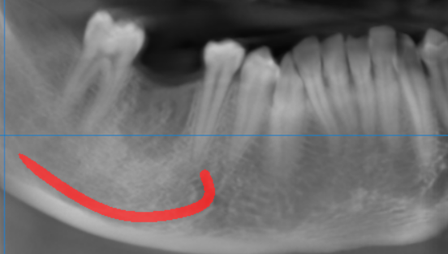

3-DIMENSIONAL VIEW

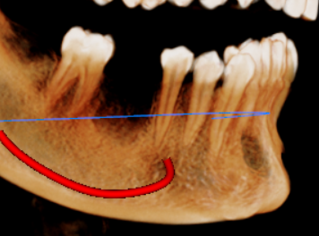

CROSS SECTIONAL VIEW

45 region | 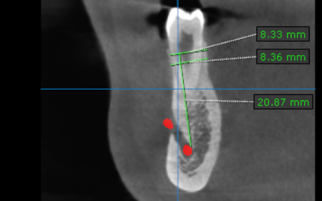
46 region | 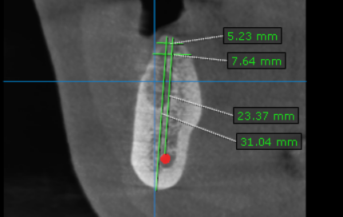
47 region | 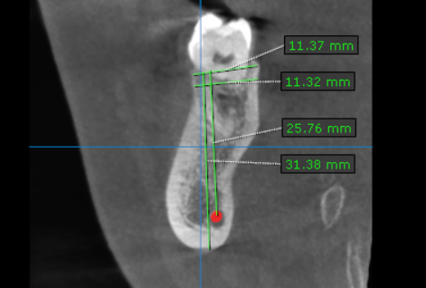

REDUCED BONE DENSITY
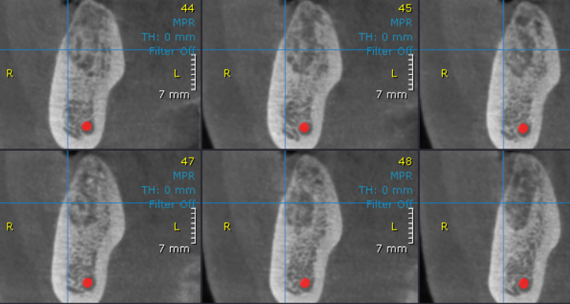

**** End of report ****

